***Subscriptions***

*What is Office 365 and how is it used?*

Office 365 is an integrated experience of apps and services, such as Word, Excel, PowerPoint, Teams, OneDrive updated monthly with new features and security.

It is used in Business, Education, and Non-profit to facilitate enterprise activities,

email (Exchange)

document sharing (SharePoint)

Storage (OneDrive)

collaboration (Teams, Yammer).

It is a subscription services, although it can be bought as one-time purchase.

*What are some of the plan comparisons?*

***Business***

Office 365 Business

$8.25 user/month

Apps: Outlook, Word, Excel, PowerPoint, Publisher (PC only), Access (PC only)

Services: OneDrive

Web & Mobile Version of Office Apps

File storage & sharing

Support & Deployment

Office 365 Business Premium

$12.50 user/month

Apps: Outlook, Word, Excel, PowerPoint, Publisher (PC only), Access (PC only) (same as 365 Business

Services: Exchange, OneDrive, SharePoint, Teams

TeamWork Communication

Email & Calendaring

Security compliance

Office 365 Business Essentials

$5.00 User/Month

Apps: No Office Apps

Services: Exchange, OneDrive, SharePoint, Teams

Support and Deployment

Security and Compliance

Email & Calendar

File Storage and Sharing

**For Home**

Office 365 Personal

$70.00/ year (Only One Person)

Apps: Word, Excel, PowerPoint, Outlook, Publisher (PC only) Access (PC only)

Services: OneDrive, Skype

1 TB total storage for 1 person, security sensitive files in OneDrive Vault

MacOS, Android, and Windows obviously

Office 365 Home

$99.99 year (Up to 6 people)

Apps: Word, Excel, PowerPoint, Outlook, Publisher (PC only) Access (PC only)

Services: OneDrive, Skype

1 TB total storage for 1 person, security sensitive files in OneDrive Vault

MacOS, Android, and Windows obviously

Office Home & Student 2019

$149.99 (for one person), (one time purchase)

Apps: Word, Excel, PowerPoint

Services: No services

**Enterprise**

Office 365 ProPlus

$12.00 user/month

Apps: Word, Excel, PowerPoint, Outlook, Publisher (PC only) Access (PC only)

Services: OneDrive

One License covers 5 phones, 5 tablets, and 5 PCs or Macs per user

No Business E-mail

24/7 Phone and Email Support

Fast Track Deployment Support with purchase of 150 seats at no extra cost

Office 365 E1

$8.00 user/month

Apps: No Desktop Apps

Services: Exchange, OneDrive, SharePoint, Teams, Yammer, Stream

Web versions of Outlook, Word, Excel, and PowerPoint, screen 10.1” or less

1 TB storage sharing with OneDrive

Host unlimited HD video conferencing meeting w/ 250 people

Host meetings up to 10,000 people with Teams live events

Advanced Personal analytics with MyAnalytics

Office 365 E3

$20.00 user/month

Apps: Word, Excel, PowerPoint, Outlook, Publisher (PC only) Access (PC only)

Services: Exchange, OneDrive, SharePoint, Teams, Yammer, Stream

One License covers 5 phones, 5 tablets, and 5 PCs or Macs per user

Email hosting with 100 GB mailbox and custom email domain address

Web versions of Outlook, Word, Excel, and PowerPoint

Unlimited Personal Cloud Storage

Host online and video conferencing meeting for up to 250 people

Host meetings for up to 10,000 people with Microsoft Teams

eDiscovery with in-place search, hold, and export?

What is this?

Office 365 E5

Apps: Outlook, Word, Excel, PowerPoint (Access PC only) (Publisher PC only)

Services: Exchange, OneDrive, SharePoint, Teams, Yammer, Power BI, Stream

Advanced Personal and organizational analytics with MyAnalytics and Power BI Pro

*Make, receive and transfer calls across a wide range of devices with Phone System*

Email hosting with 100 GB mailbox and custom email domain address

Web versions of Outlook, Word, Excel, and PowerPoint

Unlimited Personal Cloud Storage

Host online and video conferencing meeting for up to 250 people

Host meetings for up to 10,000 people with Microsoft Teams

***Admin Center***

*What is the Office 365 Admin Center?*

It is where you manage your business in the cloud.

Common Task Include

Add / Removing Users

Changing Licenses

Resetting PWs

To get to the Microsoft 365 admin center

Go to: Admin.Microsoft.com, Log-reate task

Click on App launcher, (9 dots in a cube, top left)

On the home page you can

Add Cards for task you perform frequently

To add a new card

Click Add Card button, near top

Typical Cards include

Azure Active Directory (self-service PW resets, customize sign-in and adding apps), Office 365 Users reports, Domains, Manage domain status

To remove card

Click 3 dots on card, click remove)

Adding and Removing Users

Users, in the navigation pane to the left

1) Active Users, 2) Add User, 3) Fill in Text Boxes, and PW settings then select next

4) Select Licenses to assign to user (very important) 5) In optional settings, select whether the user has no admin center access or has Admin Center Access from the radial buttons.

Typical Roles include: Exchange Admins, (Full access to Exchange online), Helpdesk Admins ( Resets PWs, and reauthenticates for all non-admins), Service Support admins (Creates service request for Azure, Microsoft 365, and monitors service health

You can sort Active Users, by display name or licenses

To enable additional features that come with subscription, in admin center

1) Select Set-up in navigation pane, you can turn on sign-in security, mobile app protection, and Data Loss prevention

*How do you view or print your bill?*

From the admin center in the navigation pane, click Billing

Then Bills and Payments

If you don’t see an invoice, filter by the last six months

To see complete details, you must download the PDF

*How do you update the payment method?*

1) Billing 2) Payment methods 3)To edit an existing card, choose three dots besides card

*How do you reset a user PW?*

When a user forgets their PW you’ll get a PW reset request in e-mail.

From admin center

1) Users 2) Active Users 3) Key icon 4) click auto generate a new pw, or set user pw. 4) The Admin user e-mail is already added, if you have a personal email you can add that. 5) select the button send e-mail and close, the user receives a email with the PW reset instructions.

*How do you allow users to reset their own PW? Self service PW request.*

To allow users to reset their own pw each time you can set-up Self-Service PW request. From admin center

1) Select settings 2) Security and Privacy 3) Azure AD Admin center 4) Users 5) Password Reset 5) Select All (other options are selected and none) 6) Save 7) The next time a user logins into an account, they’re asked for additional information. 8) They’re asked to authenticate with the phone email or both. 9) Users can now reset their own password when needed.

*How do you add a new user?*

Whenever a person joins your organization, you’ll need to add them as a new user.

From User Management card in admin center, Select the button add user

Fill in the text boxes, for First Name, Last Name, the UserName which will be their email address. Fill in PW settings

The next window (I not sure of the proper term in 365) gives you the subscription your using and available licenses.

In the next window, if you want to make them administrator under roles. Under profile info fill in additional details.

In the Next window, when you finish adding the user, you will be made aware of additional cost.

*Removing a User*

Every time an employee an employee leaves the company you must block them from accessing company files, preserve documents that they created and other admin task.

Sign in, Admin Center

Before deleting a user, edit user, so you can preserve files

1) Select employee name, Reset PW, Auto generate pw, and uncheck, make this user change their password when they first sign in.

2) Check the checkbox, send this pw in email selected, and send the pw to the admin. The select send email and close.

3) Forward their email to another user(employee) in the office who can take over their work. Expand mail settings, next to email forwarding choose edit, turn-on forward all emails sent to this mailbox, then type your email address, or the email address of the employee who will be taking over their work. This way you receive emails from partners they were working with. Leave keep a copy of forwarded email selected, (I think this just leaves a copy of the email in the old mailbox.

4) To also copy email calendar and contacts to your mailbox

1) Open Outlook, 2) Choose add account 3) Add **Their** email alongside yours, in case you need to review anything. 4) This is done from the admin outlook account.

Switch back to admin center and expand OneDrive settings

Next to sign-out choose innate, this forces the employee to sign-out the next time they use office 365.

Next to access files, click access files, follow the link to their work files on OneDrive. Select files, and select Download,.

If user used phone to access work files, select admin center, then Exchange, under recipients, choose mailboxes, select their name then under mobile devices, choose view details, then wipe data and block. And save.

As final step return to admin center, select user and return to employees name, next to product licenses choose edit. Turn-off appropriate licenses so they are no longer using that license.

*Add another admin*

When you sign up for Microsoft office 365 business, you automatically become a global admin. If you want you can make other people admins as well.

From admin center select users, Active user, choose the user you want to make admin. Then select manage roles. Select appropriate role save changes, then close window

If there is an external IT person you want to help manage your business, you can add them as a global admin.

Add User, Text boxes of names, send PW in email upon completion to the user who will become admin’s email account.

Assign licenses, select roles, choose global administrator.

*Change a username or email address*

You can do this by changing display name, alias, and email address.

From Admin center

Users, Active Users, Select User, if Jenn wants to be Jennifer, you change display name,

Choose manage contact information, change display name to Jennifer, select save changes. The new name will now be displayed in outlook and other 365 apps.

Create an alias

Now say you want to add a different email address for Jennifer,

Select name, Manage email aliases, add a new email alias, enter new alias, Jennifer can now receive emails at [Jennifer@contosoco.com](mailto:Jennifer@contosoco.com) and [jenna@rycontoso.onmicrosoft.com](mailto:jenna@rycontoso.onmicrosoft.com)

If Jennifer wants her actual email changed, select name, select manage username, type Jennifer, verify the correct domain, then select, save changes.

As a result of this change, Jennifer will need to sign into Microsoft 365 with new username and add the account to outlook.

*Move users to a different subscription*

As Users change roles they may need features that are unavailable in current subscription. When this happen you can add a new subscription that includes those features and assign licenses to the people who need them.

From Admin Center, Select billing, purchase services, review options and choose subscription you would like to add. Select Buy, and number of licenses that you need. Select checkout now, confirm order.

Change license that is currently assigned to user

Select User, Active User, Licenses and Apps, Select new subscription and deselect old subscription. License for new subscription is now assigned to this user.

You unused license you can assign to new user or remove

To remove extra license select products and services, Add/Remove Licenses,

*Create a companywide signature*

Appears on every email sent by people in your organization. Displays company contact information or legal disclaimer.

From Microsoft 365 Admin center

Select exchange, select mailflow, (add a rule, Plus sign) then apply disclaimers.

Enter a name for the rule, apply rule as required, on the do the following dropdown, verify the append the disclaimer is displayed, select enter text, then enter the text for your email signature. You can format text with HTML, if you want an image everyone can see you’ll need an image from a publicly available URL to that image. Copy image address into HTML. Select Okay,

To make sure Signature works with encrypted email, add a fallback option.

Select okay, select wrap, then okay.

Scroll down and leave the mode set to enforced.

Select save, then select yes. To apply the rule to all future messages.

*Review Usage Reports*

In The admin center office, click reports, usage reports allow you to see how employees are using the different services of your office 365 subscription.

We can see all of the different reports available by clicking reports, usage.

We can see details of the reports by clicking the cards.

Active User reports shows which reports are used most often by people in your business. You can view information specific to an individual (default settings do not show identifiable information)

Click Settings, Services & add-ins, anonymous identifier on

You now can see identifiable information, specific to an individual

*Add a new Domain*

A company might have multiple domain names that it uses for different purposes. EX: Contoso.com, & Contoso.net.

If you want to use a different spelling of contosoco.com, contosocos.com

In the admin center, select setup, get your custom domain setup select view, select manage, the select add domain, select domain, then select next

In order to receive email with this new domain, you’ll need to add it as a new email alias for each user.

Select Users, Active Users, then the email alias you want to add the email for.

Choose manage email alias, select add email alias, save changes, repeat these steps for everyone who needs an email with new domain.

***Exchange***

*Admin center*

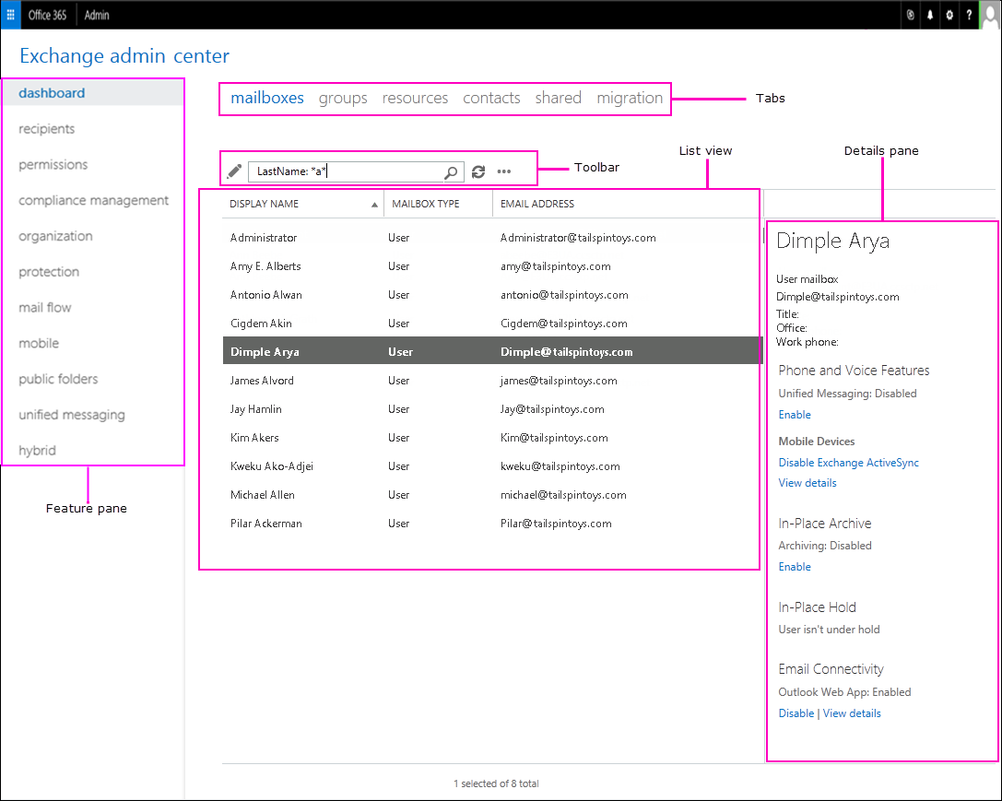

*Feature Pane*

Dashboard -overview of admin center

Recipients – view and manage mailboxes, groups, resource mailboxes, contacts, shared mailboxes and mailbox migrations

Permissions – Manage administrator roles, user roles, and Outlook on the web

Compliance management – Manage In-Place eDiscovery & Hold? (what is this), auditing, DLP, retention policies, retention tags, and journal rules

Organization – Manage organization sharing and apps for Outlook

Protection – Manage malware filters, connection filters, content filters, outbound spam and quarantine for organization

Mail Flow – Manage rules, message tracing, accepted domains, remote domains, and connectors.

Mobile – Manage the mobile devices that you allow to connect to your organization. You can manage mobile device access and mobile device mailbox policies

Public folders – Manage public folders and public folder mailboxes

*Tabs*

Are your second level of navigation. Each of the feature areas contains various tab

*Toolbar*

Some tabs have a toolbar, the toolbar has icons that perform a specific action.

Common Icons

Plus sign, Add, new

Pencil, edit

Trash Can, Delete

Magnifying glass, search

*List View*

When you select a tab, in most cases you’ll see a list view.

In Exchange Online, the viewable limit from within the Exchange admin center list view is approximately 10,000 objects

*Details Pane*

When you select an item from the list view, information about that object is displayed in the details pain.

*Centers, Me Tile and Help*

The centers tile allows you to change from one admin center to another. Me tile allows you to sign out of the EAC and sign in as a different User.

***Exchange Permissions***

Exchange Online in Office 365 includes a large set of predefined permissions, based on the Role Based Access Control (RBAC) permission model which you can use right away to easily grant permission to your administrators and users.

You can use the permission feature in Exchange Online so that you can get your new organization up and running quickly.

RBAC is also the permissions model that’s used in Microsoft Exchange Server.

*Role-based permissions*

In Exchange Online, the permission that you grant to administrators and users are based on management roles. A management role defines the set of tasks that an administrator or user can perform.

EX: Mail Recipients, defines the task that someone can perform on a set of mailboxes, contacts and distribution groups.

When a management role is assigned to an administrator or user that person is granted the permissions provided by the management role. There are two types of management roles

Administrative roles: These roles contain permissions that can be assigned to administrators or specialist users using role groups that manage a part of the Exchange Online organization such as recipients or compliance management.

End-User roles: These roles, which are assigned using role assignment policies, enable users to manage aspects of their own mailbox and distribution groups that they own. End-User roles begin with the prefix My.

Management roles give permissions to perform tasks to administrators and users by making cmdlets available to those who are assigned the roles. BC Exchange admin center (EAC) and Exchange Online PS use cmdlets to manage Exchange Online, granting access to a cmdlet gives the administrator or user permission to perform the task in each of the Exchange Online management interfaces.

*Role groups and role assignment policies*

Role Groups: Assigning permissions to administrators and specialist users.

Role Assignment Policies: enable you to grant permissions to end users to change settings.

*Role Groups:* Every administrator who manages Exchange Online must be assigned at least one or more roles. Some admins are assigned to more than one role

To make it easier to assign multiple roles to an administrator, Exchange Online includes role groups.

When a role is assigned to a role group, the permissions granted by the role are granted to all the members of the role group. Many roles, many group members at once.

They’re used only with administrative roles, and not end-user roles.

EX: Role groups members can be Exchange Online users and other role groups

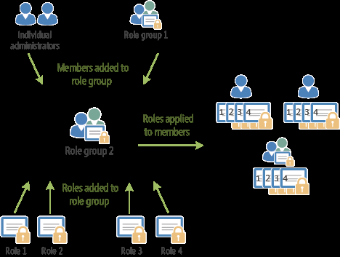

Role Groups

Discovery management: Administrators or users who are members of the discovery management role group can perform searches of mailboxes in the Exchange online organization for data that meets specific criteria and can also configure legal holds on mailboxes.

Help Desk: - by default enables members to view and modify the Outlook on the web (formerly known as Outlook Web App) options of any user in the organization. These options might include modifying the user’s display name, address and phone number.

Does include options that aren’t available in Outlook on the web options.

Help Desk (Administrators): doesn’t have any roles assigned to it. It’s a member of the View-Only organization management role group and inherits the permissions provided by that role group. Can’t be managed in Exchange online. You can add members to this role group by adding users to the PW administrator office 365 role.

Organization Management: Have administrative access to the entire Exchange Online organization and can perform almost any task against any Exchange Online Object, with some exceptions, such as the Discovery Management role.

Recipient Management: Administrators who are members of the Recipient management role group have administrative access to create or modify Exchange Online recipients within the organization

Administrators who are members of the Recipient management role group have administrative access to create or modify Exchange 2013 recipients within the Exchange 2013 organization.

Records Management: Users who are members of the Records management role group can configure compliance features, such as retention policy tags, message classifications, and mail flow rules (also known as transport rules)

View-Only Organization Management: Administrators who are members of the view only organization management role group can view the properties of any object in the Exchange organization

Compliance Management: users who are members of the Compliance Management role group are responsible for compliance, to properly configure and manage compliance settings within Exchange in accordance with their policy

If the built-in role groups in Exchange Online don’t match the job function of your administrators, you can create role groups and add roles the them.

*Role Assignment Policies*

Exchange Online provides role assignment policies so that you can control what settings your users can configure on their own mailboxes and on distribution groups they own. These settings include: display name, contact info, voice mail settings, and distribution group membership.

Role assignment policies are added directly to mailboxes and each mailbox can only be associated with one role assignment policy at a time.

Of the role assignment policies in your organization, one is marked as default. Default role assignment policy is associated with new mailboxes that aren’t explicitly assigned a specific role assignment policy when they’re created.

Permissions are added to role assignment policies using end-user roles. End-user roles begin with My and grant permissions for users to manage only their mailbox or distribution

groups they own. They *can’t* be used to manage any other mailbox, only end-user roles can assign to role assignment policies.

When an end-user role is assigned to a role assignment policy, all of the mailboxes associated receive the permissions granted by the role.

*Office 365 permissions in Exchange Online*

Office 365 roles and Corresponding Exchange roles

Office 365: Global Administrator Exchange Online: Organization Management

Office 365: Password Admin Exchange Online: Password Administrator

When you add a user to either the Global administrator or PW administrator Office 365 roles, the user is granted the rights provided by the respective Exchange Online role group.

Users can be granted administrative rights in Exchange Online w/o adding them to Office 365 roles. This is done by adding the user as a member of an exchange Online role group, when added directly to Exchange Online role group, they’ll receive the permissions granted by that role group in Exchange online.

Users can be added to any of the role groups listed in the “Built-in role groups table” in role groups with the exception of the Company Administrator and Help Desk Administrators role group.

*Work with role groups*

To manage your permissions using role groups in Exchange Online, we recommend that you use the EAC. The EAC provides simple dialog boxes, such as the new role group dialog box to perform these task.

Exchange Online includes several role groups that separate permissions into specific administrative areas.

If these existing role groups provide the permissions your administrators need to manage your Exchange Online organization, you only add your administrators as members of the appropriate role groups.

After you add administrators to a role group, they can administer the feature that relate to that role group.

**Important**

If an administrator is a member of more than one role group, Exchange Online grants the administrator all of the permissions provided by the role groups he or she is member of.

If none of the role groups included with Exchange Online have the permission you need, you can use the EAC to create a role group and add the roles that have the permissions you need.

If there’s an existing role group that has some, but not all, of the permissions you need, you can copy it and make changes to create a role group, without affecting the original role group. By adding and removing roles to and from role groups, you turn on and off administrative features for members of that role group.

*Work with role assignment Policies*

To manage the permissions that you grant end users to manage their own mailbox in Exchange Online, use EAC.

***SharePoint***

SharePoint Online is a cloud-based service that helps organizations share and manage content, knowledge and applications to:

* Empower teamwork
* Quickly find information
* Seamlessly collaborate across the organization

Before you dive into building and configuring your organization’s SharePoint environment, there are a few things you should think about. For example, how will you manage sites with the objective to collaborate (team sites) broadcast and share content for viewing (communication sites)

*The process of setting up SharePoint is divided into three steps*

1) Set up your SharePoint environment Who does this? Global admins and SharePoint admins in Office 365

Plan your SharePoint hub sites

Collaborate with guest

Train your users

Manage Site Creation

*Plan your SharePoint hub sites*

Hub sites help your organize your intranet.

*Setting the stage*

Provide an important building block for your intranet, are the “connective tissue” you use when organizing families of team’s sites and communication sites together.

One of the key principles of modern intranets based on SharePoint is that each unit of work should get a separate site collection to optimally manage governance and growth over time. Each communication site and Office 365 group-connected team sites is created as a site collection that can have its own permissions.

A hub site (most commonly created from a communication site) should also be considered its own unit of work that brings together numerous other sites.

Seems like site collection, communication site and hub sites are all pretty similar

In the past many organizations used subsites to create connective tissue for their intranets, using the site collection’s shared navigation to connect sites and the hierarchical structure of subsite relationships to nest sites within sites.

However, subsites are a physical construct reflected in the URL for content, if you reorganize your business relationships, you will break all the intranet relationships in your content.

Subsites also create challenges related to governance, because many features in SharePoint apply to all sites within the site collection, whether you want them to or not.

What always happens in Business? Change!

This is a key benefit of SharePoint hub sites; the model relationships as links rather than hierarchy or ownership, so that you can adapt to the changes in the way you work in a dynamic changing world.

*Getting Started*

Before you start making hub sites, let’s recap the three things hub sites give you:

Share navigation and brand

Roll-up of content and search

A home destination for the hub.

Possible business outcomes related to your intranet/ hub site. Successful intranets(hub sites) include the following elements

Communication- A home page that includes news from around the organization to keep employees informed overall navigation, links to key tools and info, …

Content- A place for the functional parts of the organization such as HR, Legal, and IT to offer their services to the rest of the company.

Actions and Activities: Links to time- tracking system or the expense report form and a place where managers can approve expenses or timesheets

Collaboration

Culture

Mobility

Search

Emphasis for each of these elements can vary based on organizational priorities and to some extent, the digital maturity of the organization.

Office 365 provides three main building blocks to help you create your intranet in a way that allows you to configure experiences that align with your business, your employees, and your readiness.

Team Sites (collaboration)

Communication Sites (Communication)

Hub Sites (Connection)

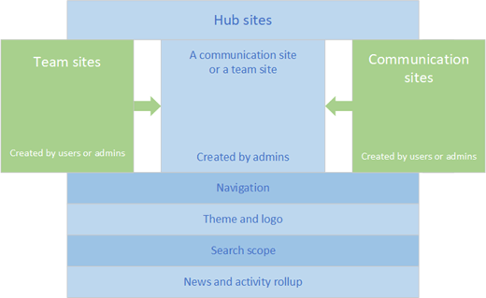

At their core, the three types of building blocks share a common structure. Ex: they share the same set of internal web parts.

However, there are some fundamental differences in intent, usage expectations, governance ( including how they are created), and how and which web parts you might use on each type of site.

Team Sites

Primary Business Objective: Collaboration, Collaborate

When you want to create a place where the members of a work group or project team can work together on project deliverables, plan an event, track status, or exchange ideas, you want a team site. Team sites are connected by default to an Office 365 group to deliver a full range of communication and collaboration tools, including Microsoft Teams and Planner.

Content Authors: All members are content authors, who jointly create and edit content

Governance: Norms are typically defined by the team, best way to get work done

Permissions: Office 365 group, plus SharePoint groups and permission levels

Created by: Site owner

Communication Site

Primary Business Objective: Communication

When you want to broadcast a message, tell a story, share content for viewing (but not editing), or showcase services or people, you want a communication site. Communication site owners often want to include an engagement component - for example an "Ask Business Development" area on a site communicating information about business development. This is a great place to connect a Yammer group.

Content Authors: Small number of content authors and a much larger number of content readers and consumers

Governance: Policies are often determined by an organization:

Permission: SharePoint Group

Created by: Site Owner

Hub Site

Primary Business Objective: Connect

When you want to create a shared experience for a family of related sites—to discover related content by rolling up site activity and news, organize related sites so that they share a common navigation, and apply a common look and feel.

Content Authors: Hub site owner, Defines the shared experiences for hub navigation and theme. Hub site members create content on the hub site as with any other Share point site.

Governance: Determined by each owner of the associated site based on the type of site and organizational policies

Permission: Same as original site type. Hub site do not alter an associated site’s permissions.

Created by: Global Admin

*What should be a hub site?*

Hub sites complement the search experience by helping you discover information in context of what it is. In the new world where all team and communication sites are peer site collections, information architects must think about creating experiences that will allow intranet users to find what they need in multiple “find” scenarios:

I know it exist, and I know where it is

I know it exist, but I don’t know where it is

I don’t know if it exist.

These scenarios are enabled with a combination of navigation, search, and discovery (serendipity) and should be a factor in how you design and organize your hub sites.

One of the important capabilities that hub sites enable is the serendipitous discovery of info bc they can surface contextually relevant content from sites you may not follow but are associated with the hub.

As a starting point in your hub planning think about hub sites for key functions that your users need to get work done – for example: HR, Finance, Communications, or Public Relations, Legal, and IT

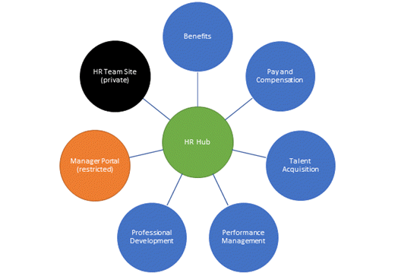

Using the guiding principle of creating a site for each unit of work, you can think about an HR family of sites that could include picture above.

In the classic intranet model, you might have created an HR site and used subsites to support each HR function.

In the new flat world of modern SharePoint sites, the HR family is connected using the HR hub to provide that connective tissue for navigation within the family and to provide an opportunity to serendipitously discover content on a related member of the family when users navigate to the HR home.

EX: if you're on the HR hub reading a news announcement about open enrollment because you're in the process of onboarding a new employee, you might be happy to know that a new version of the "Welcome to the Company" onboarding toolkit was just released on the Talent Acquisition site. Likewise, if you're trying to find the HR team's office sharing policy, you'll appreciate being able to limit your search to only the HR-affiliated sites, rather than the entire company.

You don’t have to have a hub site for every function.

However, when a function provides multiple logically different services (as in the HR example), it’s a good place to provide a single starting place for your users.

Think about how a user might search within a hub for specific info that would register but not be applicable if searched on the enterprise site.

Some Organizational functions have an enterprise-wide scope but a regional or product execution.

Ex: Sales department that may have sites for sales regions and sites for location based offices. This becomes difficult to manage with a hierarchy .

Picking a hub may create some angst because an individual site can be associated with only one hub, (So we can not have Fabrikam and Contoso associated with the same hub)

But keep in mind that news activity and highlighted content is based on search, so it’s possible to have conent from one site appear on multiple hub home pages.

A hub will default to only showing content from it’s own associated sites, but it’s easy to configure it to include other related sites as well, even if those sites are associated with different hubs.

There is no “one size fits all” way to determine how to align sites to a hub in this scenario. Ask these questions

Who is your audience and what do they need to accomplish?

How do people who need the information get their work

Align your hub to create experiences that enable the user first. You may want to think about how people in each work group think about the work work they do by aligning regional sites with the function,

NOTE: A site can only associate with a hub family. However, the hub families can be connected to one another using links either on the page or in the hub navigation.

*How should I organize my Hub site*?

Though creating a hub site must be done by the global or SharePoint admin in Office 365, planning, managing and organizing the hub site is the responsibility of the hub site owner. Organizing concept for hubs are

Association

A site becomes part of a hub family by Associating a SharePoint site with a hub site. When creating a hub site, SharePoint admins should allow only certain site owners to associate sites with the hub.

After a SharePoint admin gives a site owner permission to associate their site with a hub site, the site owner can choose to associate the site with the hub. When they do, the site inherits the hubs site theme and shared navigation. Content from their site will roll up to the hub site, and the site will be included in the hub site search scope

Associating with the hub does not automatically add the site to the hub navigation. Hub site owners determine which sites are included in navigation.

Navigation

The hub site owner determines which sites are reflected in the shared navigation, and can also include links to other resources. This navigation appears at the top, below the suite bar. Most of the time, you will want to add associated sites to your hub navigation. That's one of the benefits of the experiences that you can enable with a hub. Your hub navigation can have up to three levels, which affords a lot of opportunity to organize your hub family in a way that helps users discover and find relevant content.

However, you may not want to add every associated site to your navigation and you may want to consider adding sites that aren't associated to the navigation. Consider the following as you plan your hub navigation.